

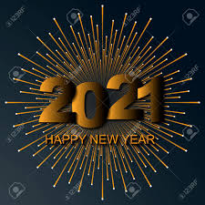
New Year eve 31-12-2020
18.30h – 19.00h Cocktail reception
19.00h – 19.45h violin
19:45h – 20.45h live singer
20. 45h – 21.15h belly dancer
21:15 -21:4 5h Tanoura show
21:4 5-22:30h Animation show
22:30 -00:00h dj& count down

Wishing you merry Xmas and happy New Year 2021

