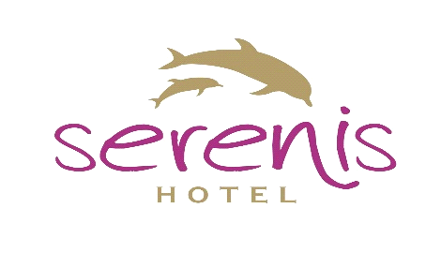

SERENİS HOTEL
2022 SUMMER SEASON

CONTACT İNFORMATION

Hotel : SERENİS HOTEL
Official Category : 5 Yıldız
Address : Kumköy – Side – Antalya / Türkiye
Telefon : +90 242 756 15 00
Fax : +90 242 756 10 60
Web Address : www.serenishotel.com
E-mail : info@serenishotel.com

GENERAL İNFORMATION

Side : 3 km
Manavgat : 7 km
Airport : 65 km
Beach distance : 500 m
Area : 29.000 m²
Floor / Lift : 06 Floor / 3 Lift

Rooms
Total Room : 358
Total Bed : 766

Standard Room : 18 m²
Bunkbed Room : 18 m²
Family Room : 28 m²
Handicapped Rooms : 23 m²

All Rooms : Air Condition, Safe, LCD T.V.,Minibar, Phone
Ground : Laminant
Balcony : Chair
Bathroom : Shower Cabin or Bathtub , Hair Dryer, Phone.

POOLS : There are 6 Swimming pools

Main Pool : 975 m²
Relax Pool : 450 m²
Mini Aqua park : 180 m²
Wave Pool : 576 m²
Aqua park : 150 m²
İndoor Pool : 77 m²

Beach : Distance to beach 500mt.Free Shuttle Service, Beach Bar, Sunbed, Beach shead WC, Shower. First beach towel is free For every change per towel 0,50 cent fee.

Meals

07.30 - 10.00 Breakfast (Restaurant)
10.00 - 10.30 Late Breakfast (Restaurant)
12.30 - 14.00 Lunch (Restaurant)
12.00 - 15.30 Snack (Pool)
12.00 - 15.30 Snack (Beach)
16.00 - 17.00 Coffee and cake (Pool)
19.00 - 21.00 Dinner (Restaurant)
23.30 - 00.00 Soup time (Restaurant)

DRİNKS

Lobby bar 10.00 – 24.00
Pool bar 10.00 – 24.00
Beach 10.00 – 17.00

*Import drinks are not included to all inclusive concept.
*Alcoholic drinks are not allowed to children under 18 years.
*Champagnes , Special Wines and Canned drinks are with charge.
*Popcorn ,Cotton Candy, Room Service and Pressed Fruit Juice , Safe, Wifi are with Fee
*Alcoholic drinks are not served during the Breakfast
*Wi-Fi free only in Lobby area, in all Rooms and Public areas with charge
*The above listed activities and service hours can be changed by the hotel management with prior information.
*Per Room key or towel card costs 10 € if lost .
*C/out time is 12:00 - for late c/out pls. ask to reception

SPORT AND ENTERTAİNMENT

* Water Gymnastik * Billard (With Fee)l *Game Place *Aqua park
* Table Tennis * Mini Club (4-12 age) *Mini Disco
* Water ball
* Boccia

