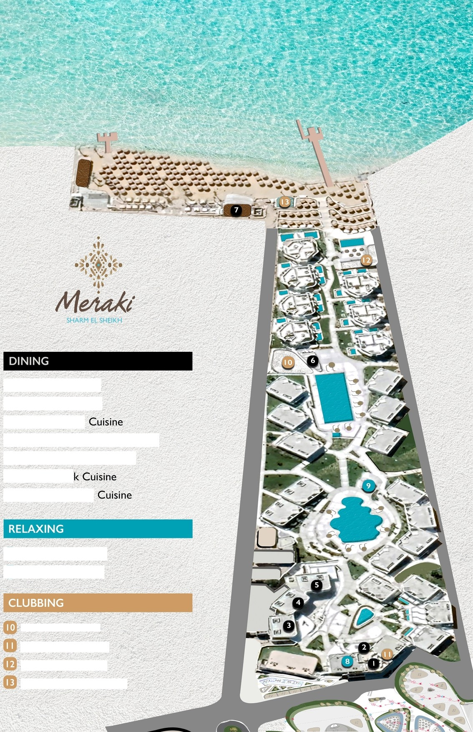

Burger Boulevard The Noodle Tribe Basilico Italian
Munchery International Buffet Mumm Lebanese Cuisine Yades Gree
Felucca Seafood

Ophelia Lobby Bar Euphoria Pool Bar

Floaters Pool Bar Velocity Sports Bar Utopia Beach Club Carpe Diem Beach Bar

