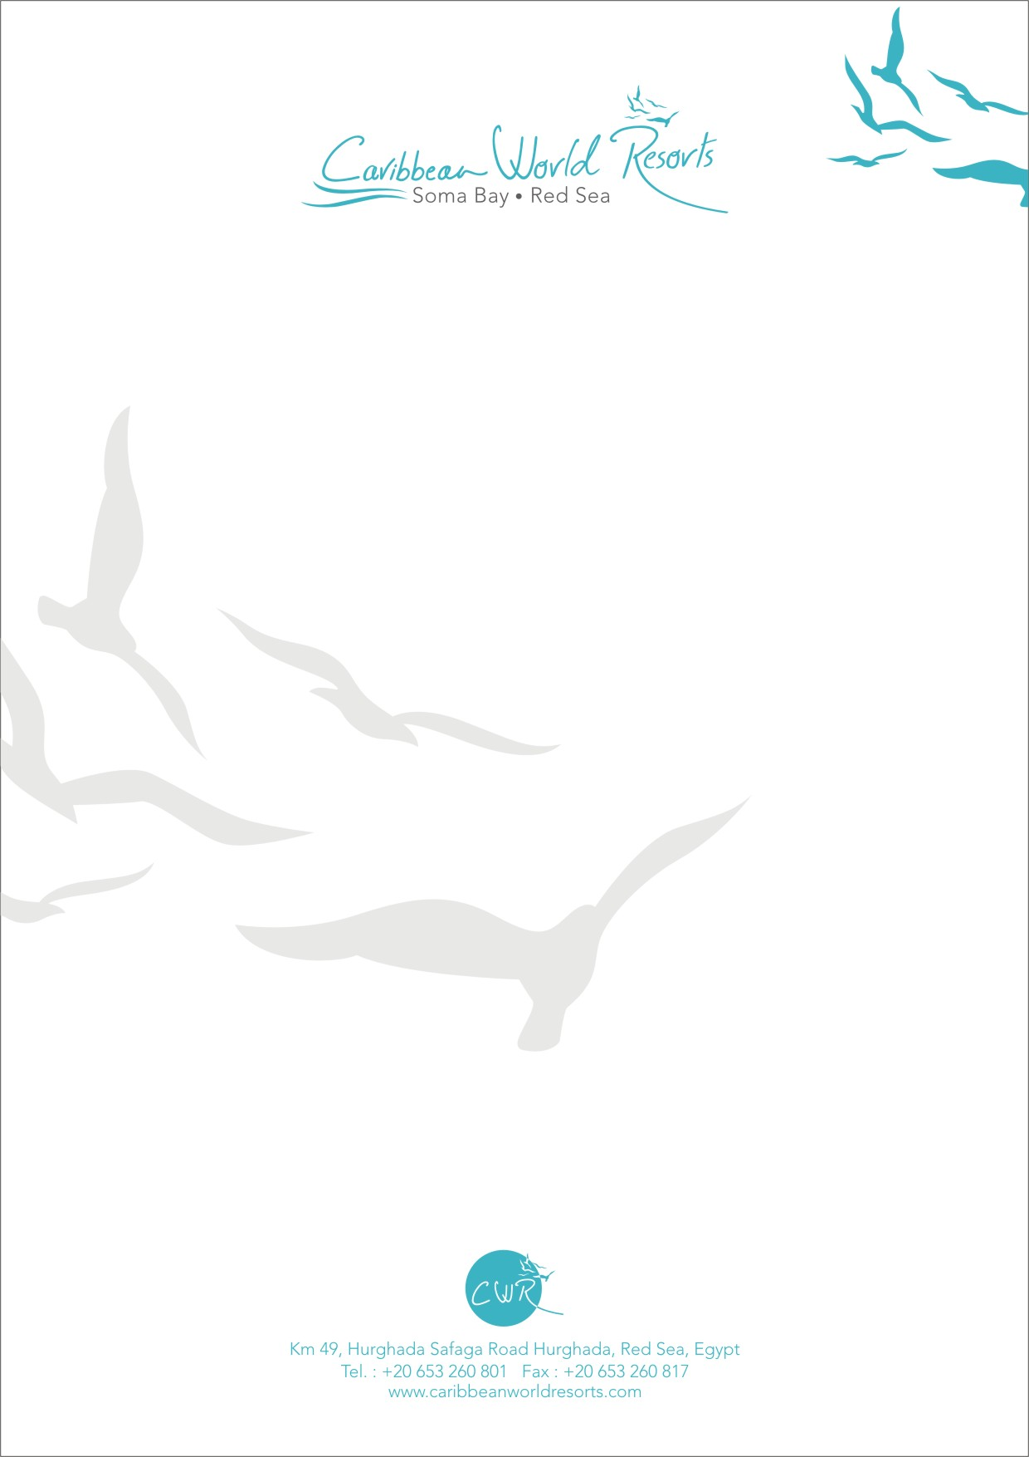
`

New Year Night 2023 in Caribbean World Resort

Saturday 31th of December

CWR New Year

From 18:30 pm
Celebrate in style
It's not long until the festive season countdown starts, we are delighted to invite you to join us for Great delicious New Year dinner and New Year Eve Party

Have a fantastic night with us

New Year Night in Caribbean World Resort

- 18 : 30 : Special Cocktail display at Fountain Area
- 19 : 00 : Guest Entrance to the Buffet , Meet , Greet Guests and Escort them to the tables
- 19 : 00 : Gala Buffet opening
- 19 : 30 : Life Singer
- 20 : 10 : Life Singer
- 20 : 40 : Caribbean Show
- 21 : 10 : Belly Dance & Tanoura
- 21 : 20 : Life Singer
- 22 : 00 : Caribbean Show
- 22 : 50 : Life Singer
- 23 : 30 : DJ
- 00 : 00 : Count Down , Happy New Year 2023 , continues DJ and Animation Team.
- 00 : 45 : Life Singer
- 01 : 15 : DJ & free dance till end of the Party

