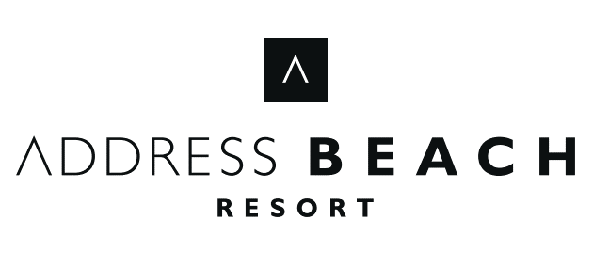  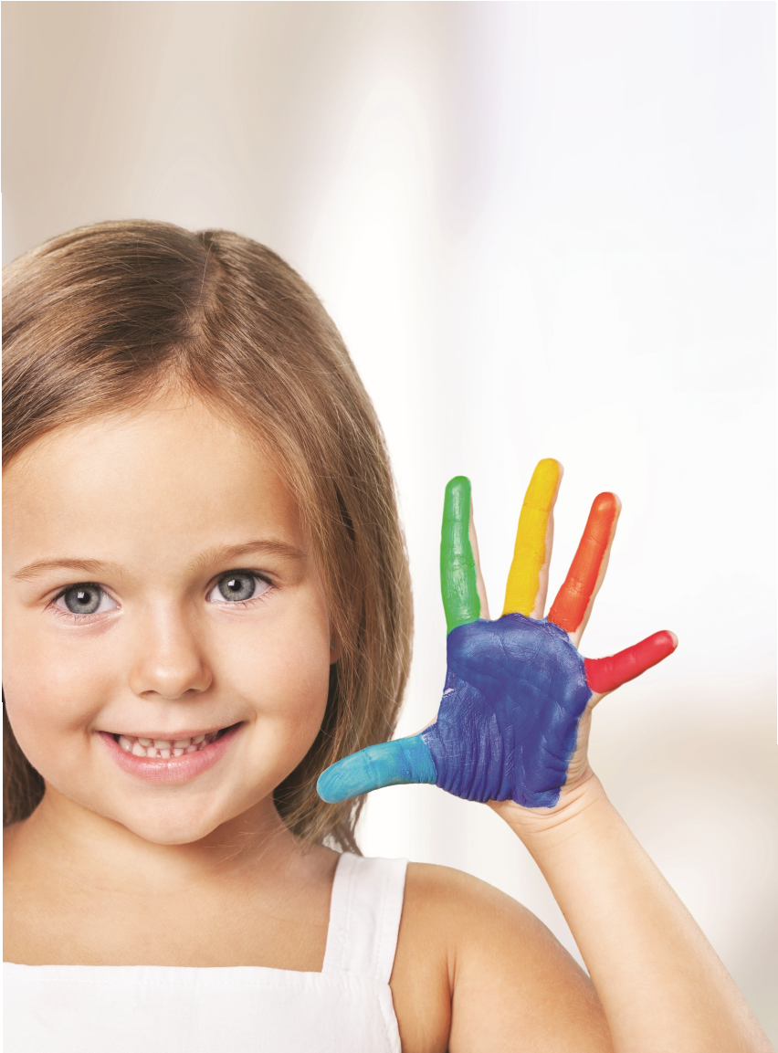  Kids Club Summer Camp  10am 4-pm  PLAY YOUR WAY  PO BOX 214042, JBR THE WALK, DUBAI, UAE  T +971 4 8798867  FITNESSATBEACHRESORT@ADDRESSHOTELS.COM  ADDRESSHOTELS.COM
  Monday  10:00 - 12:00nn Splash Pad/Pool/Beach  Parachute, collecting balls, volleyball, badminton  12:00- 1:00pm  Arts & Crafts  Handpainting  1:00pm 2:00pm  Lunch  2:00pm – 3:00pm  Games  Balloon Tennis/ Balloon Bending  Kids Zumba/Yoga  3:00pm – 4:00pm  Pass and collect bangles | Tuesday  10:00 – 12:00nn  Splash Pad/Pool/Beach  Parachute, collecting balls, volleyball, badminton  12:00 –1:00pm  Arts & Crafts  Loom band & bracelate  1:00pm 2:00pm  Lunch  2:00pm – 3:00pm  Games  Egg & spoon Relay Race  Kids Zumba/Yoga  3:00pm – 4:00pm  Collect balloons on | Wednesday  10:00 – 12:00nn  Splash Pad/Pool/Beach  Parachute, collecting balls, volleyball, badminton  12:00 – 1:00pm  Arts & Crafts  Paper decoration  1:00pm 2:00pm  Lunch  2:00pm – 3:00pm  Games  Musical Chairs  Kids Zumba/Yoga  3:00pm – 4:00pm  Collect straws in fork | Thursday  10:00 – 12:00nn  Splash Pad/Pool/Beach  Parachute, collecting balls, volleyball, badminton  12:00 – 1:00pm  Arts & Crafts  Origami, Butterfly, flower  1:00pm 2:00pm  Lunch  2:00pm – 3:00pm  Games  Car race/ Chicken Dance  Kids Zumba/Yoga  3:00pm– 4:00pm  Binggo Card/ Puzzle | Friday  10:00 – 12:00nn  Splash Pad/Pool/Beach  Parachute, collecting balls, volleyball, badminton  12:00 – 1:00pm  Arts & Crafts  Sand Arts  1:00pm 2:00pm  Lunch  2:00pm – 3:00pm  Games  Tag games  Kids Zumba/Yoga  Jingga  3:00pm – 4:00pm  Pass and collect bangles

